THE MOON

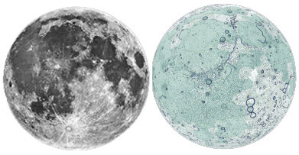

The most ancient formations of the lunar surface are the 4+ billion year old highlands, and the areas where the surface is so densely covered with craters, that a newly created one surely wipes away a few earlier craters. The large basins and the smallest craters were all scooped out by asteroids and space debris coming from the outer space and hitting the Moon. The “seas” (mare) are actually ancient lava plains, which filled up the earlier large impact basins with many layers of lava. The rocks on the lunar surface have been broken up, pulverised by “space dust” for billions of years, creating moon dust covering the entire surface. The ’face’ of the Moon has been unchanged for billions of years. It looked almost the same in the age of the dinosaurs, when the continents of the Earth had completely different shapes. The youngest formations are the light-rayed craters. There is no visible sign of water: even the meandering channels of the Moon were formed by volcanic lava.

Body type: moon
Body composition: rocky
Atmosphere: —
Liquid: —
Weather: The rocky regolith is cold during night (120K/-150°C/-240F) in low latitudes, hot during daytime when rocks and dust are in the sun (it’s never cloudy, but the sky is always black – there is no air) (390K/+120°C/250F). Very cold, dark in permanently shadowed craters at the poles (40K/-232°C/-385F). Dangerously high solar radiation (solar wind) when the Moon is not in Earth's solar wind shadow. Micrometeorite (few mm to cm large) impacts always possible.
Endogenic features: lava plains (maria)
Exogenic features: none
Cosmogenic features: impact craters of every size everywhere, lunar dust
Common features: craters
Rare features: lava channels, small volcanic domes.
Life limiting parameter: no atmosphere
Nomenclature: We follow the traditions set in the 1640s when features of the Moon were named. Maria (seas of basalt) are named after meteorological features (rain, storms etc.) because at that time people believed that the Moon affects the terrestrial weather, especially morning dew. Craters are named after famous scientists, philosophers and also commemorate astronauts.
Highest point: Far side highland
Lowest point: A crater within South Pole Aitken Basin, a very ancient, very large basin on the far side.
Age of the surface: cratered highlands are older than 3.9 billion years, smooth maria are about 3 billion years.
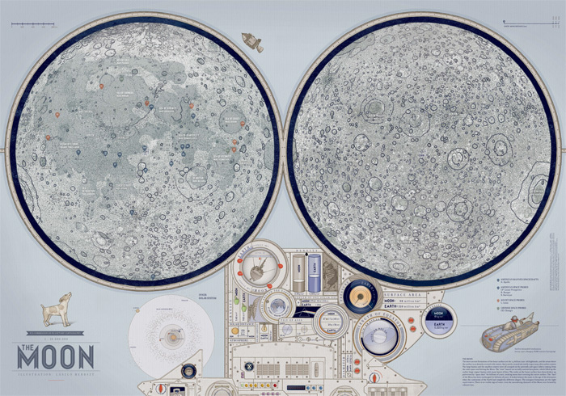

Moon map: (Illustrator: László Herbszt) The map of the Moon plays with craters and commemorative names: inside some of the selected craters, the person it is named for is shown. Some other craters have funny creatures inside. Visually, the map shows many minute details and is drawn in the style of pre-20th-century engravings. The visual design of the control panel uses the Apollo spacecraft’s control panels as a model. The map shows the mare-terra albedo distinction along with crater rays and also highlights the optically invisible basin outlines, which can only be seen in topographic maps.

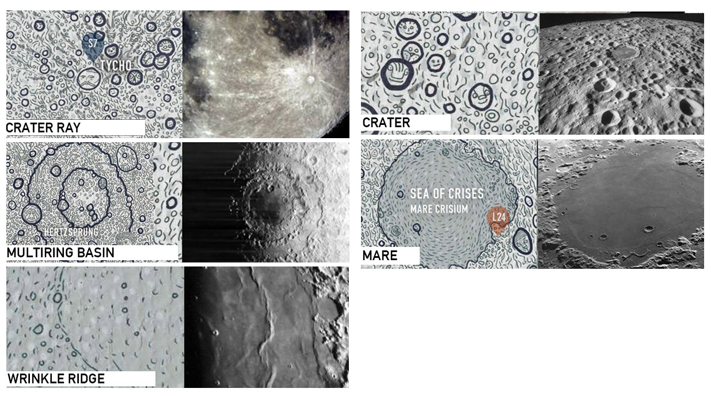

INSTRUCTIONS / THE MOON
ACTIVITY 1
- Draw the Equator
- Mark the North Pole and South Pole in both hemispheres with letters N and S
- Write the name of the body
ACTIVITY 2 Read the handout, and underline words you don’t understand.
Graphic map. Using the map, draw a generalized (simplified) sketch map, showing the outlines of only the largest and most important features (draw several types of features, e.g., cracks and craters). You can use colors and/or lines.
- Volcanic
  - Outlines of the dark areas (maria, seas of solid basalt within large impact basin)
- Impact
  - Bright rayed, young craters (Tycho, Copernicus)
  - Multiring impact basins (Mare Orientale)
  - Ringed craters (Schrodinger)
- Most famous landers: Apollo 11–17

ACTIVITY 3 Your landing site. Where would you land? which place you find the most exciting for exploration? Find YOUR landing site. Mark it with a symbol. Name your landing site (s). Write down the names next to the symbol.
ACTIVITY 4 Names. After the graphic part is finished, create the nomenclature: write the names of the features you have drawn next to the feature itself. Write three names (you can add more later) onto the map. You can use different colors or letters for each feature type (e.g, capital letters for continents, red color for the lava channel etc. -- be consistent).
ACTIVITY 5 Make up a weather forecast for "tomorrow", based on the Weather information in the handout. Choose at least three places, and show weather data: display the min/max temperature in your unit (C or F) with LARGE numbers. Consider that on towards the poles it is colder. Next to the numbers, show the weather with a graphic symbol you design: clear (sunny), cloudy, rainy, foggy or any interesting, special weather phenomenon you learn from the handout. Find min/max temperature data on the map's control desk and additional information on the handout.
ACTIVITY 6 Design a flag for the planet or moon, and draw it on the map, based on the characteristics of the body (weather, color, geology etc).
ACTIVTY 7 Draw a map legend where YOUR symbols are explained on the map. You may group them by process (e.g., exogenic (atmospheric, aeolian), endogenic (volcanic, tectonic) and impact processes). Write down the title “LEGEND” and explain your symbols and indicate which feature it corresponds to.

