Worksheet 1: Where On Earth Am I?
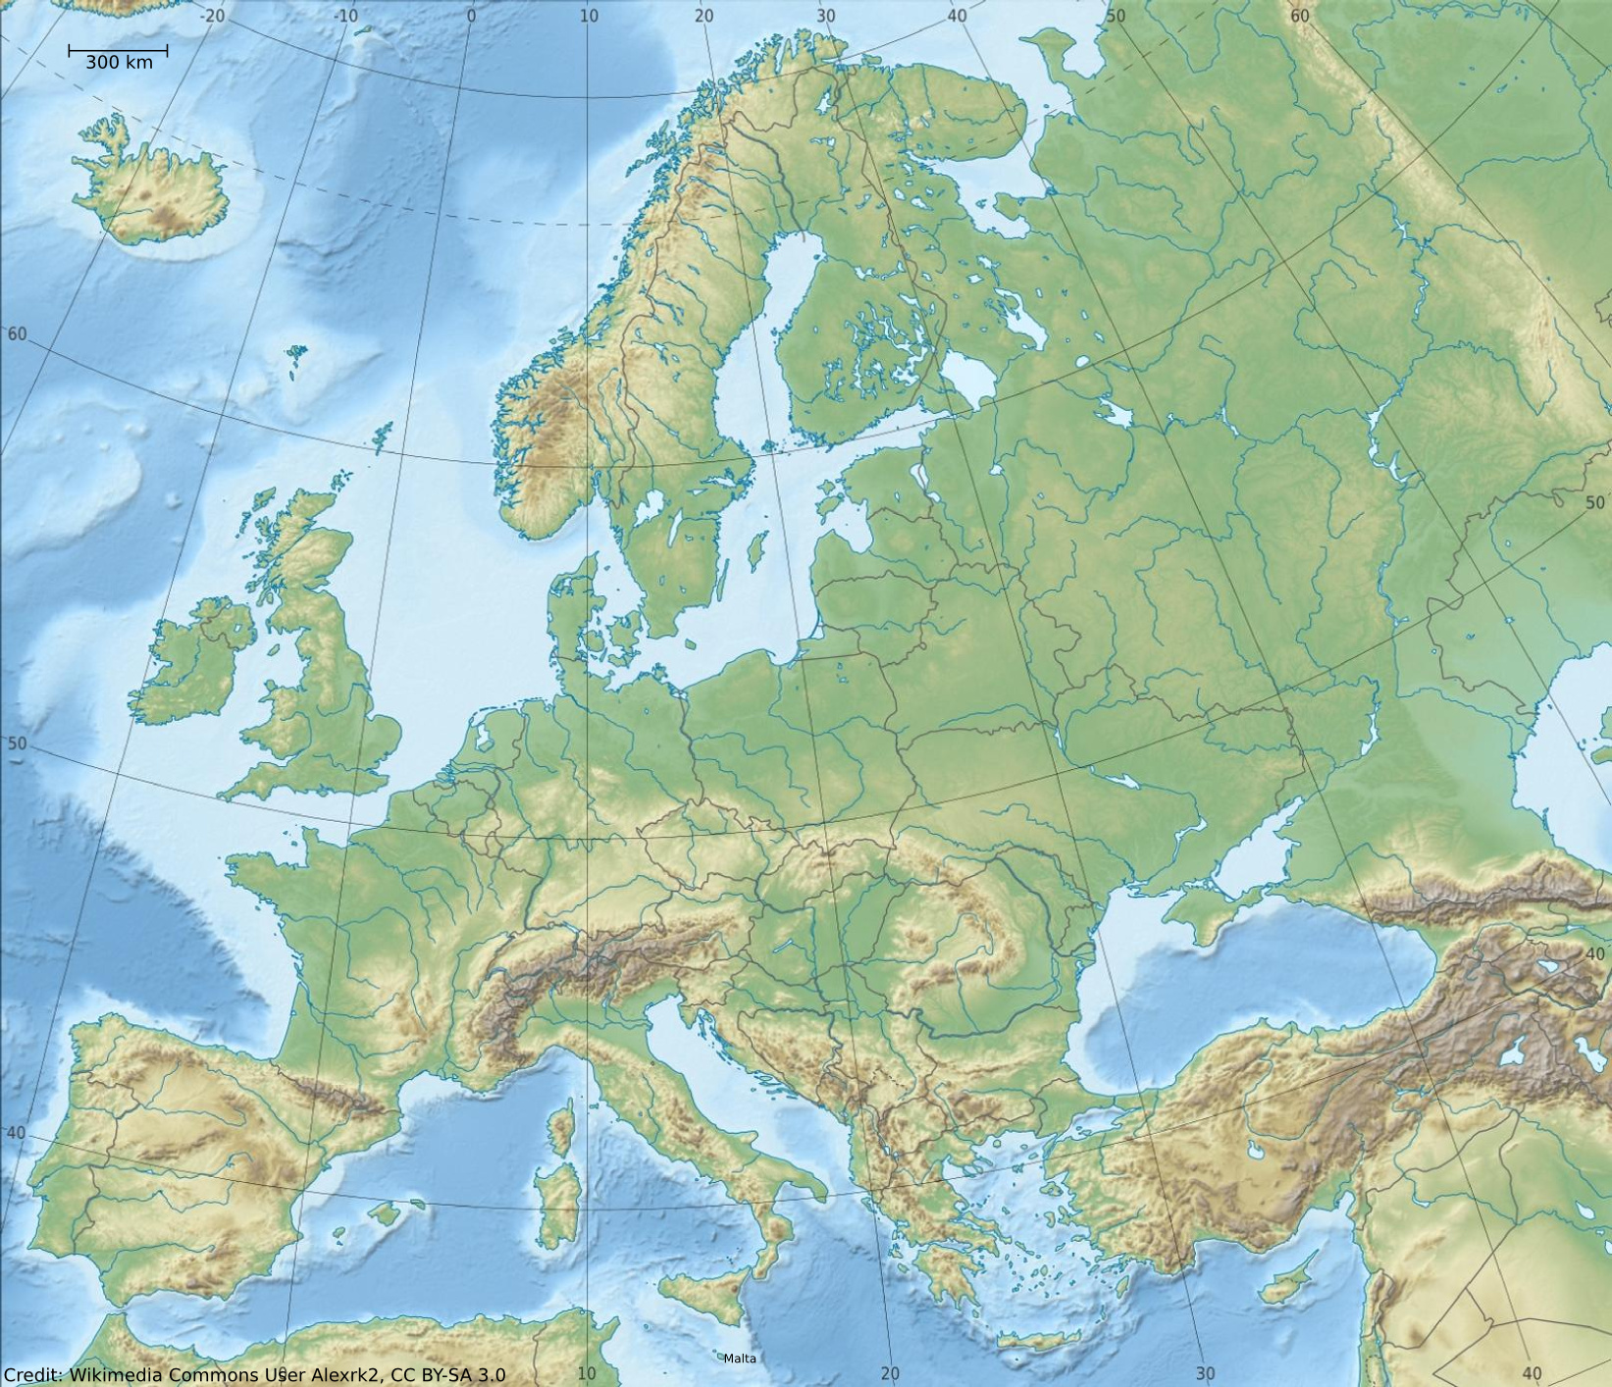
Identify the countries of Europe. The borders are indicated by grey lines. Can you name the capitals of each country?

